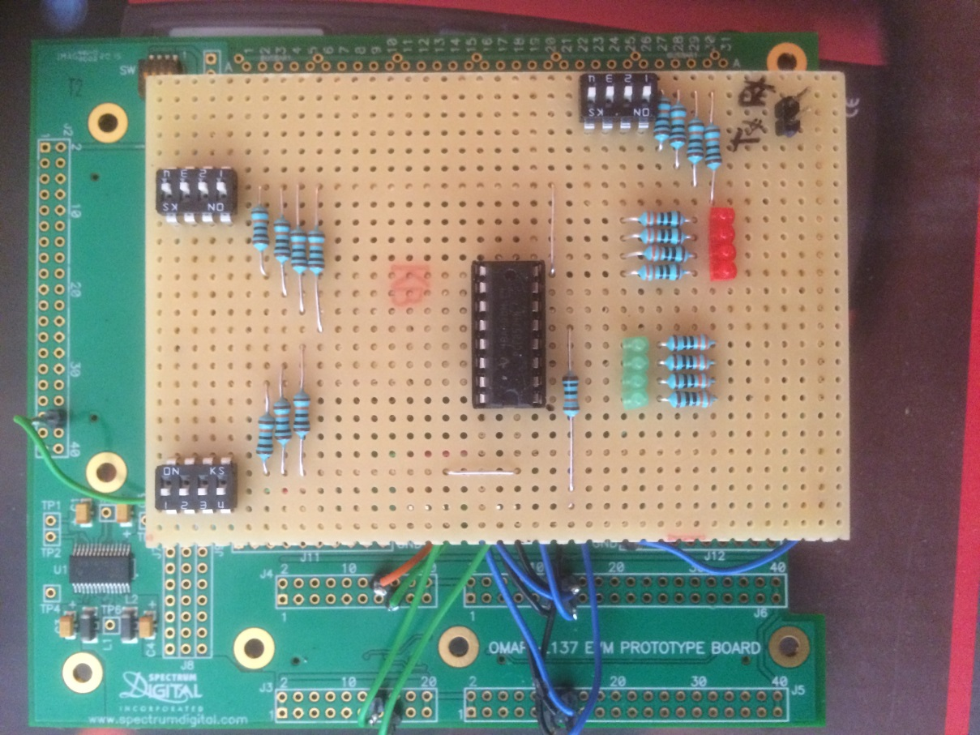

UART-Rx

GPIOs

LEDs

GPIOs

Switch

I2C

Inputs

I2C

LEDs

UART-Tx

ADR